CSS-HTML Exam —-4bhrs

1. Design a form with input fields for name, email, and message.

<!DOCTYPE html>

<html>

    <head>

    </head>

    <body>

        <h1>Form</h1>

        <form>

            <label for="Name">Name:</label>

            <input type="text"><br><br>

            <label for="email">Email:</label>

            <input type="email"><br><br>

            <label for="message">Message:</label>

            <textarea name="message" id="message cols="30" rows="5">

            </textarea><br><br>

            <input type="submit">

        </form>

    </body>

</html>

Output:

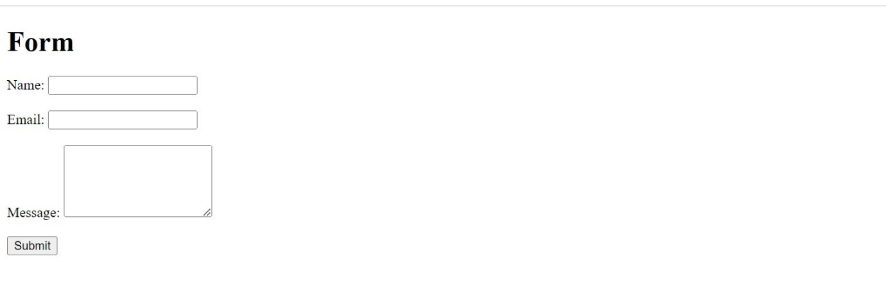

1. Create a three-column layout using CSS grid or flexbox.

<!DOCTYPE html>

<html>

    <head>

        <style>

            div{

                width: 400px;

                height: 100px;

                display: flex;

            }

            p{

                border: 5px solid;

            }

        </style>

    </head>

    <body>

       <h1>Three Column Layout</h1>

       <div>

           <p>This is a first box of column layout.</p>

           <p>This is a second box of column layout.</p>

           <p>This is a third box of column layout.</p>

        </div>

    </body>

</html>

Output:

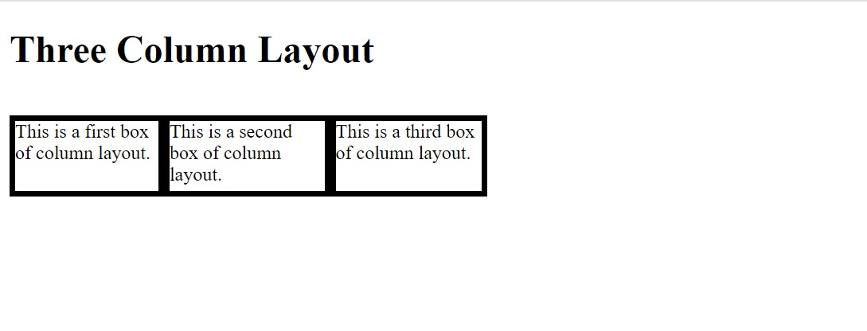

1. Make a responsive website that adjusts its layout for different screen sizes.

<!DOCTYPE html>

<html>

    <head>

        <meta charset="utf-8"

        name="viewport"

        content="width=device-width,

                initial-scale=1.0"/>

        <style>

            body{

                text-align: justify;

                text-align: center;

                min-width:500px;

                min-height: 500px;

            }

        </style>

    </head>

    <body>

       <h1>Responsive website layout</h1>

       <p>HTML Responsive Web Design is a dynamic approach to web design that ensures web pages look good on all devices. It involves the automatic adjustment of HTML elements such as resizing, hiding, showing, shrinking, and expanding, depending on the device and screen size used. This means the web pages will automatically adapt to the screen size of the device in use, providing an optimal viewing experience.</p>

       <p>We will demonstrate different examples of how we can create an HTML responsive web design so that it will adjust according to the screen size of the device used.</p>

    </body>

</html>

Output:

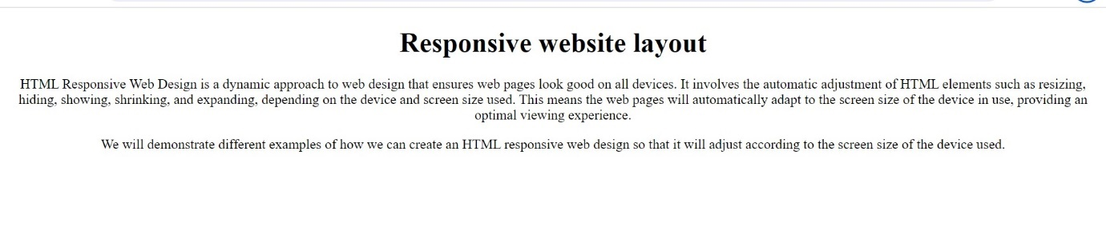

1. Style a button to change its appearance when hovered over.

<!DOCTYPE html>

<html>

    <head>

        <style>

                input:hover{

                    background-color: red;

                }

        </style>

    </head>

    <body>

        <h4>Hover</h4>

        <p>Hover the mouse on button to change color to red.</p>

        <input type="button" value="Hover here">

    </body>

</html>

Output:

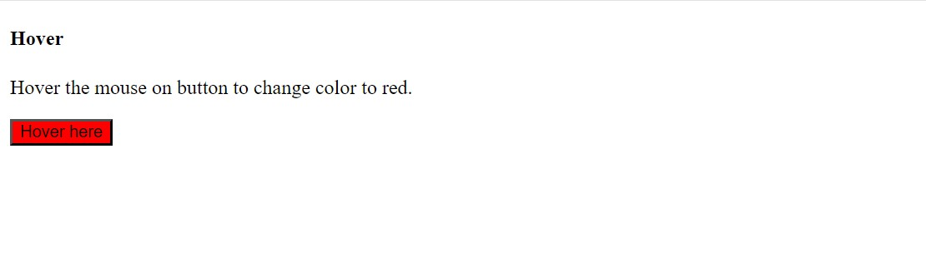

1. Create a dropdown menu using HTML and CSS.

HTML:

<!DOCTYPE html>

<html>

    <head>

        <link rel="stylesheet" href="5.css">

    </head>

    <body>

        <h1>Dropdown Menu</h1>

        <label for="menu">Menu:</label>

        <select name="Menu" id="menu">

            <optgroup class="box">

                <option value="Item 1">Item 1</option>

                <option value="Item 1">Item 2</option>

                <option value="Item 1">Item 3</option>

                <option value="Item 1">Item 4</option>

                <option value="Item 1">Item 5</option>

            </optgroup>

            <input type="submit">

        </select>

    </body>

</html>

CSS:

body{

    background-color: aquamarine;

}

.box{

    background-color: rgb(107, 107, 198);

}

input{

    background-color: green;

    margin-left: 20px;

}

Output:

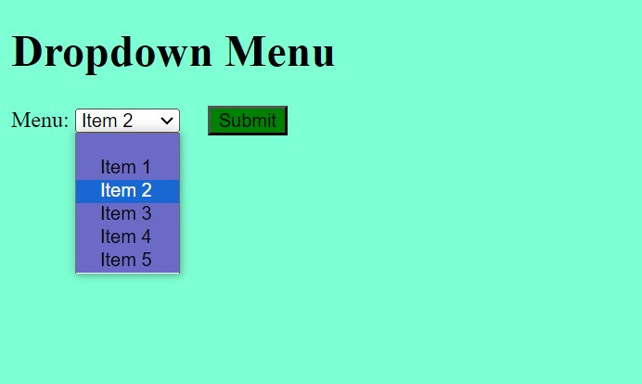

1. Build a simple slideshow using HTML, CSS, and JavaScript.

<!DOCTYPE html>

<html>

  <head>

    <style>

  .box{

  width: 400px;

  height: 300px;

  position: relative;

  }

  .left, .right {

  position: absolute;

  top: 50%;

  width: 10px;

  padding: 16px;

  color: rgb(171, 171, 49);

  background-color: brown;

  }

  .right {

  right: 0;

  border-radius: 3px 0 0 3px;

  }

  .left:hover, .right:hover {

  background-color: rgba(25, 42, 198, 0.8);

  }

    </style>

  </head>

  <body>

    <h2>Slide show</h2>

    <div class="box">

      <div class="mySlides fade">

        <img src="https://www.carandbike.com/_next/image?url=https%3A%2F%2Fc.ndtvimg.com%2F2022-01%2F0d2m0qkg_car_625x300_12_January_22.jpg&w=3840&q=75" style="width:100%">

      </div>

    <div class="mySlides fade">

        <img src="https://images.autotrader.com/hn/c/a98305bf5d714c4f94ffcdfd6e2407f8.jpg" style="width:100%">

      </div>

      <div class="mySlides fade">

        <img src="https://o.aolcdn.com/hss/storage/midas/bfd7f8e2a223e3a31044651617243392/200702281/001-2015-volvo-xc90-first-edition628opt.jpg" style="width:100%">

      </div>

      <a class="left" onclick="plusSlides(-1)">❮</a>

      <a class="right" onclick="plusSlides(1)">❯</a>

    </div>

  <script>

  let slideIndex = 1;

  showSlides(slideIndex);

  function plusSlides(n) {

  showSlides(slideIndex += n);

  }

  function currentSlide(n) {

  showSlides(slideIndex = n);

  }

  function showSlides(n) {

  let i;

  let slides = document.getElementsByClassName("mySlides");

  let dots = document.getElementsByClassName("dot");

  if (n > slides.length) {slideIndex = 1}

  if (n < 1) {slideIndex = slides.length}

  for (i = 0; i < slides.length; i++) {

    slides[i].style.display = "none";

  }

  slides[slideIndex-1].style.display = "block";

  }

  </script>

  </body>

</html>

Output:

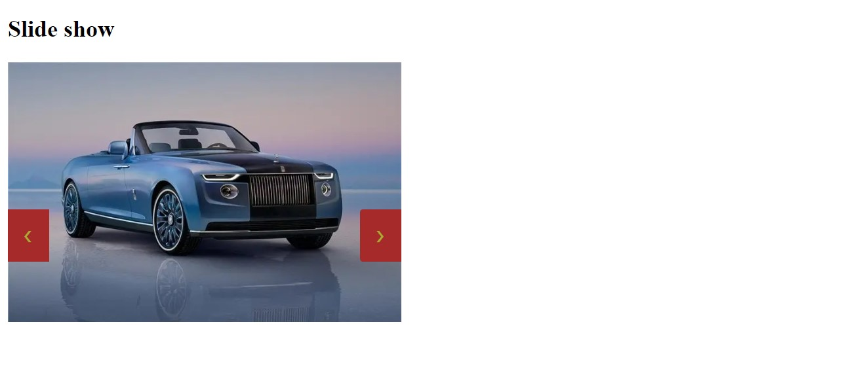

1. Design a pricing table with multiple plans using HTML and CSS.

HTML:

<!DOCTYPE html>

<html>

    <head>

        <link rel="stylesheet" href="7.css">

    </head>

    <body>

       <h1>Pricing Table</h1>

       <table>

        <caption>Mobile Recharge Plans</caption>

        <th>Network</th>

        <th>Yearly plan</th>

        <th>Monthly plan</th>

        <tr>

            <td>Jio</td>

            <td>₹2299</td>

            <td>₹199</td>

        </tr>

        <tr>

            <td>Idea</td>

            <td>₹2399</td>

            <td>₹249</td>

        </tr>

        <tr>

            <td>Airtel</td>

            <td>₹2349</td>

            <td>₹229</td>

        </tr>

       </table>

    </body>

</html>

CSS:

table{

    border: 5px solid red;

    height: 200px;

    width: 300px;

}

th,td{

    border: 2px solid;

    text-align: center;

}

th{

    background-color: rgb(117, 162, 71);

}

td{

    background-color: rgb(187, 91, 188);

}

Output:



1. Make a sticky navigation bar that stays at the top of the page when scrolling.

<!DOCTYPE html>

<html>

    <head>

        <style>

            nav{

                position: sticky;

                position: fixed;

                background-color: aqua;

            }

            div{

                border: 2px solid;

                width: 300px;

                height: 200px;

                overflow: scroll;

            }

        </style>

    </head>

    <body>

       <h1>Sticky navigation Bar</h1>

       <div>

           <nav>

               <a href="">Home</a>

               <a href="">About</a>

               <a href="">Services</a>

               <a href="">Contact Us</a>

            </nav><br>

            <p>HTML is the language of the web, used by billions of websites to create the pages you see every day. Want to learn HTML from scratch and make your web pages? This tutorial is for you!</p>

            <p>In this HTML tutorial, you will learn how to use HTML to create and style web pages. You will start with HTML fundamentals, such as basic HTML tags and their attributes, classes, layout, and responsiveness. Then, you will move on to advanced HTML5 topics, such as HTML forms, media, APIs, and more. By the end of this tutorial, you will have a solid foundation in HTML.</p>

        </div>

    </body>

</html>

Output:

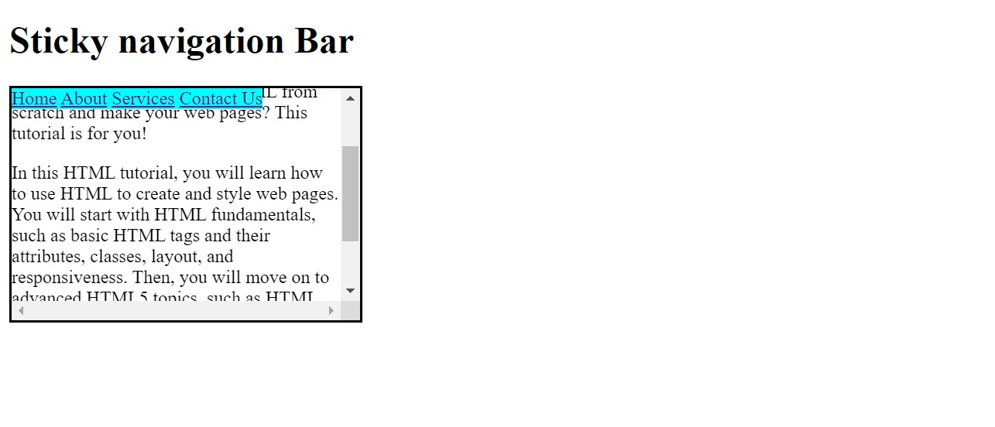

1. Implement a hover effect on images that enlarges them slightly.

<!DOCTYPE html>

<html>

    <head>

        <style>

            img{

                height: 300px;

                width: 300px;

            }

            img:hover{

                transform: scale(1.2);

                transition:transform 1s;

            }

        </style>

    </head>

    <body>

       <h1>Hover on images</h1>

       <img src="https://st2.depositphotos.com/1141099/6198/i/450/depositphotos_61983329-stock-photo-historic-charminar.jpg" alt="Image 1">

       <img src="https://avatars.mds.yandex.net/i?id=b507a2b8d9382967a186c654f1eeaa74-5262078-images-taas-consumers&n=27&h=480&w=480" alt="Image 2">

    </body>

</html>

Output:

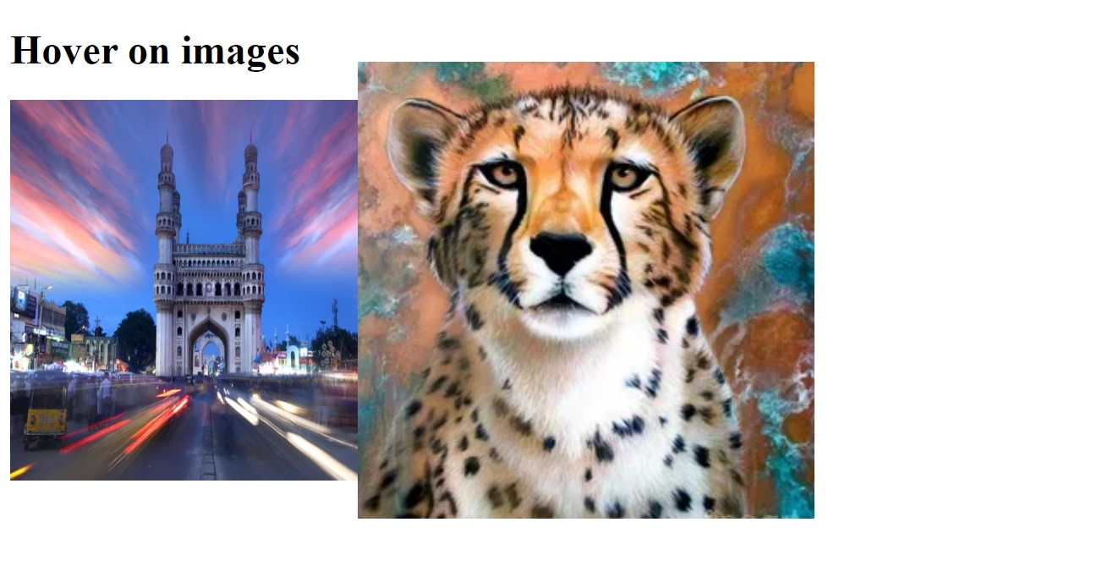

1. Create a login form with HTML and style it using CSS.

<!DOCTYPE html>

<html>

    <head>

        <style>

            form{

                border: 3px solid;

                border-radius: 30px;

                width: 400px;

                height: 200px;

                text-align: center;

                padding-top: 50px;

                background-color: burlywood;

            }

        </style>

    </head>

    <body>

        <h1>Login Form</h1>

        <form>

            <label for="Username">Usename:</label>

            <input type="text"><br><br>

            <label for="password">Password:</label>

            <input type="password"><br><br>

            <input style="background-color: rgb(152, 166, 62);" type="submit">

        </form>

    </body>

</html>

Output:

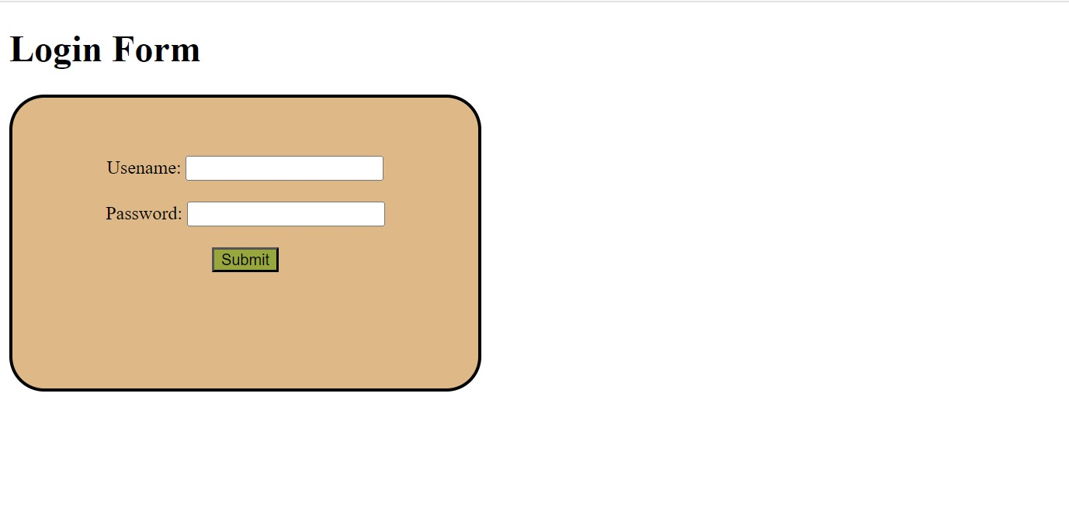

1. Build a responsive gallery that displays images in a grid format.

<!DOCTYPE html>

<html>

    <head>

        <style>

            img{

                height:100px;

                width: 100px;

            }

            div{

                display: grid;

                }

        </style>

    </head>

    <body>

       <h2>Gallery with grid layout</h2>

       <div>

           <img src="https://images.unsplash.com/photo-1604085572504-a392ddf0d86a?q=80&w=1000&auto=format&fit=crop&ixlib=rb-4.0.3&ixid=M3wxMjA3fDB8MHxzZWFyY2h8Mnx8b3JhbmdlJTIwZmxvd2VyfGVufDB8fDB8fHww" alt="Image 1">

           <img src="https://i.pinimg.com/originals/86/90/14/869014ea87e157354d2326a5961b20e0.png" alt="Image 2">

           <img src="https://nurserylive.com/cdn/shop/products/nurserylive-plants-hibiscus-gudhal-flower-pink-plant-16968932622476.jpg?v=1634221747" alt="Image 3">

           <img src="https://cms.interiorcompany.com/wp-content/uploads/2024/01/aster-attractive-flower-images.jpg" alt="Image 4">

        </div>

    </body>

</html>

Output:

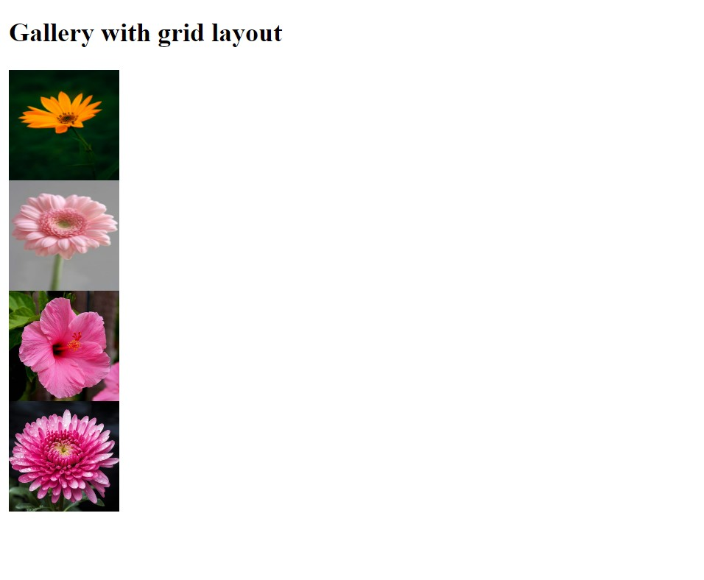

1. Style text to have different fonts, sizes, and colors on the same page.

<!DOCTYPE html>

<html>

    <head>

        <style>

            h1{

                font-style: normal;

                color: blue;

                font-family: 'Courier New', Courier, monospace;

            }

            h3{

                font-size: 50px;

                color: crimson;

                font-family:cursive;

                margin-top: 5px;

                margin-bottom: 5px;

            }

            h6{

                font-size: 20px;

                color: fuchsia;

                margin-top: 5px;

            }

            p{

                font-size: 20px;

                font-style: italic;

                color: brown;

            }

        </style>

    </head>

    <body>

       <h1>Text Styling</h1>

       <h3>Web development</h3><hr color="green">

       <h6>HTML</h6>

       <h6>CSS</h6>

       <h6>JavaScript</h6>

       <p>These are used to create web pages.</p>

    </body>

</html>

Output:

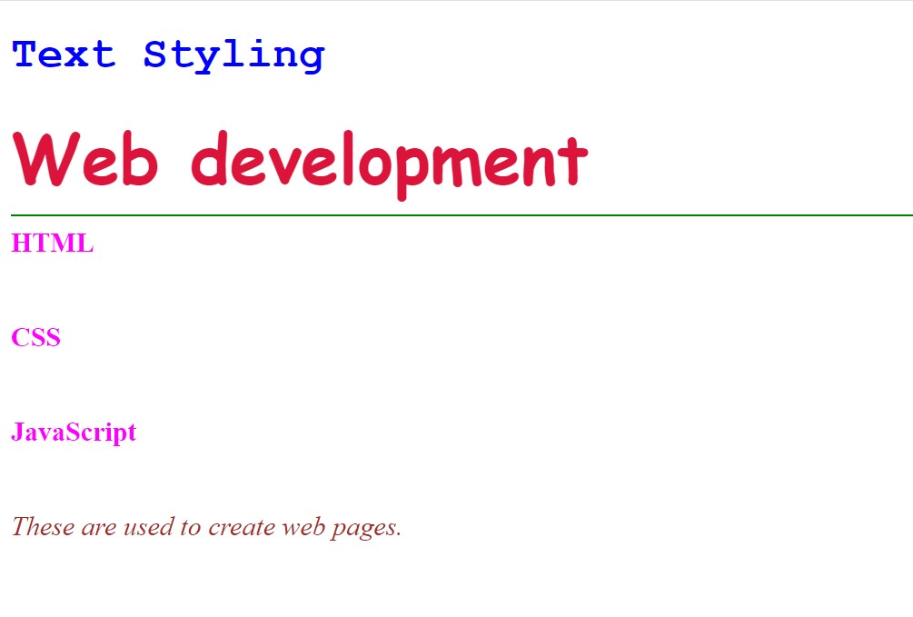

1. Design a footer that stays at the bottom of the page, regardless of content height.

<!DOCTYPE html>

<html>

    <head>

        <style>

            div{

                background-color: cornsilk;

                border: 2px solid;

                height: 200px;

                width: 500px;

                overflow: scroll;

            }

            footer{

                position: sticky;

                background-color: rgb(87, 102, 180);

            }

        </style>

    </head>

    <body>

       <h1>Footer</h1>

       <div>

            <h3>Greemus</h3>

        <p>Greemus Software Technologies Pvt Ltd was incorporated early 2013 with a key initiative of developing business solutions. The company’s main objective had been to be a one stop Solution provider for all IT needs and IT Enabled Services. Greemus as a Company is built on the core believes of business ethics, strong process, uncompromising attitude towards quality delivered. With the help of strong individuals,

            core professionals and highly qualified man power to achieve objectives of growth, keeping up the pace with the trends and technological up gradations on par with the

            industry.</p>

                <footer>

                    Greemus Software Technologies Pvt. Ltd.,Hyderabad,500081.

                </footer>

        </div>

    </body>

</html>

Output:



1. Make a horizontal scrolling website using CSS overflow property.

<!DOCTYPE html>

<html>

    <head>

        <style>

            p{

                border: 3px solid;

                height: 100px;

                width: 400px;

                overflow: auto;

                white-space: nowrap;

            }

        </style>

    </head>

    <body>

        <h1>Horizontal Scroll</h1>

        <p>The position property in CSS tells about the method of positioning for an element or an HTML entity and the positioning of an element can be done using the top, right, bottom, and left properties. These specify the distance of an HTML element from the edge of the viewport. </p>

    </body>

</html>

Output:

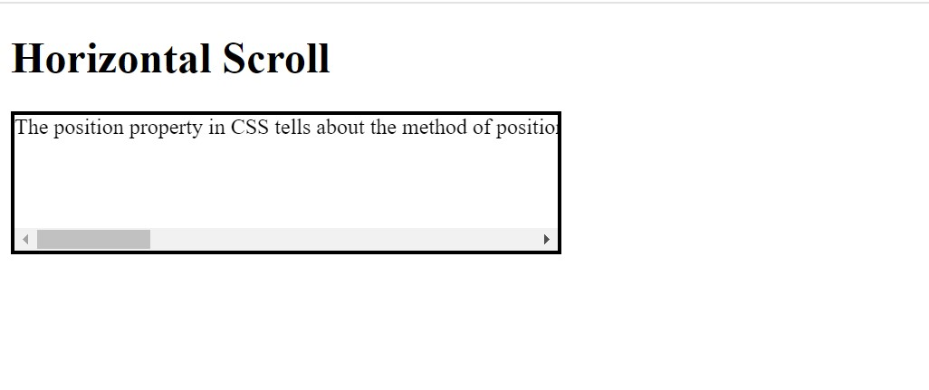

1. Create a progress bar using HTML and CSS.

<!DOCTYPE html>

<html>

    <head>

        <style>

            progress{

                background-color: rgb(76, 158, 76);

            }

            body{

                background-color: burlywood;

            }

        </style>

    </head>

    <body>

        <h1>Progress bar</h1>

        <progress value="77" max="100">

        </progress>

        <p>77% completed</p>

    </body>

</html>

Output:

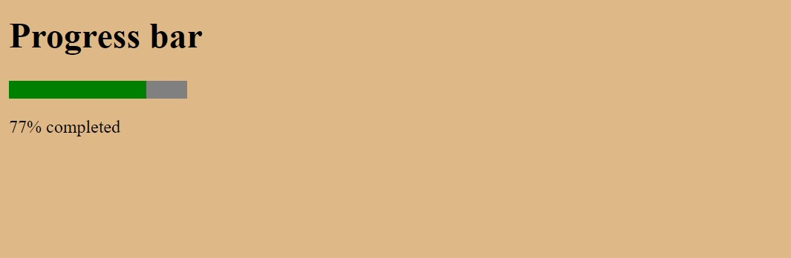

1. Implement a CSS animation on an element, such as a spinning effect.

<!DOCTYPE html>

<html>

    <head>

        <style>

            div{

                width: 200px;

                height: 200px;

                border: 10px solid rgba(154, 61, 61, 0.155);

                border-radius: 50%;

                border-top: 10px solid red;

                animation: spin 2.5s linear infinite;

                margin-left: 50px;

            }

            @keyframes spin{

                0%{

                    transform:rotate(0deg);

                }

                100%{

                    transform:rotate(360deg);

                }

            }

        </style>

    </head>

    <body>

       <h2>Spinning</h2>

       <div>

       </div>

    </body>

</html>

Output:

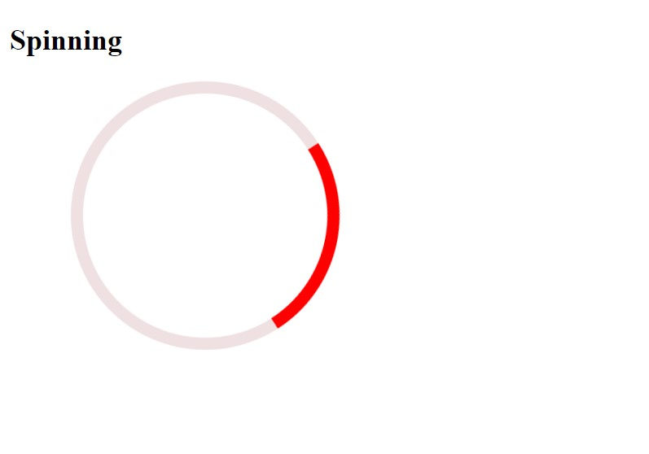

1. Build a tabbed content section using HTML, CSS, and JavaScript.

<!DOCTYPE html>

<html>

<head>

    <style>

        .container {

    border: 5px solid;

}

[data-tab-info] {

    display: none;

}

.active[data-tab-info] {

    display: block;

}

.tab-content {

    color: rgb(63, 65, 168);

}

.tabs {

    border-bottom: 2px solid;

    background-color: rgb(16, 153, 9);

    font-size: 25px;

    color: rgb(0, 0, 0);

    display: flex;

}

.tabs span {

    background: rgb(16, 153, 9);

    padding: 10px;

    border: 2px solid;

    margin: 3px;;

}

.tabs span:hover {

    background: rgb(168, 121, 54);

}

</style>

</head>

<body>

<div class="container">

<div class="tabs">

    <span data-tab-value="#tab_1">Tab A</span>

    <span data-tab-value="#tab_2">Tab B</span>

    <span data-tab-value="#tab_3">Tab C</span>

</div>

<div class="tab-content">

    <div class="tabs__tab active" id="tab_1" data-tab-info>

        <h3>HTML</h3>

        <p>HTML stands for HyperText Markup Language. <br>

            It is the standard language used to create and design web pages on the internet. <br>

            It was introduced by Tim Berners-Lee in 1991 at CERN as a simple markup language. </p>

    </div>

    <div class="tabs__tab" id="tab_2" data-tab-info>

        <h3>CSS</h3>

        <p>CSS, or Cascading Style Sheets, is the secret sauce that styles all the websites you visit. <br>

            It’s a simple language that controls how HTML elements (like text, images, and buttons) are displayed on a webpage. </p>

    </div>

    <div class="tabs__tab" id="tab_3" data-tab-info>

        <h3>JavaScript</h3>

        <p>JavaScript is the most powerful and versatile programming language used in the web. <br>

            It is a lightweight, cross-platform, single-threaded and interpreted programming language. <br>

            It is a commonly used programming language to create dynamic and interactive elements in web applications.</p>

    </div>

</div>

</div>

<script>

const tabs = document.querySelectorAll('[data-tab-value]')

const tabInfos = document.querySelectorAll('[data-tab-info]')

tabs.forEach(tab => {

    tab.addEventListener('click', () => {

        const target = document

            .querySelector(tab.dataset.tabValue);

        tabInfos.forEach(tabInfo => {

            tabInfo.classList.remove('active')

        })

        target.classList.add('active');

    })

})

</script>

</body>

</html>

Output:

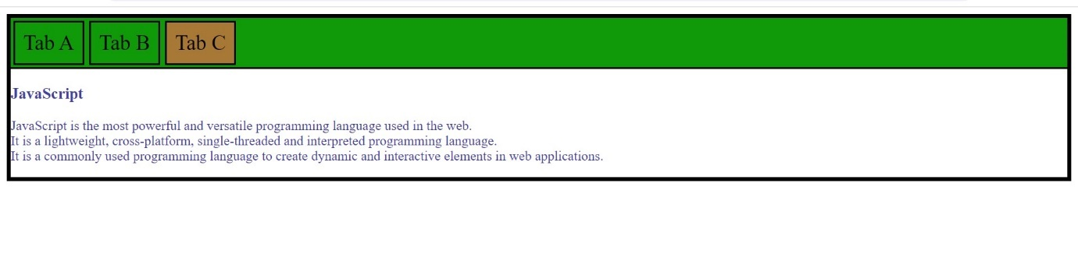

1. Design a responsive carousel/slider for showcasing images.

<!DOCTYPE html>

<html>

    <head>

        <style>

            img{

                width: 500px;

                height: 300px;

                border: 5px solid rgb(192, 32, 58);

                border-radius: 40px;

            }

        </style>

    </head>

    <body>

        <h2>Responsive slider for images</h2>

        <div>

            <img class="slide" src="https://burst.shopifycdn.com/photos/photo-of-a-cityscape-with-a-ferris-wheel.jpg?width=1000&format=pjpg&exif=0&iptc=0" alt="Image 1">

            <img class="slide" src="https://i0.wp.com/picjumbo.com/wp-content/uploads/beautiful-nature-mountain-scenery-with-flowers-free-photo.jpg?w=600&quality=80" alt="Image 1">

            <img class="slide" src="https://images.ctfassets.net/hrltx12pl8hq/28ECAQiPJZ78hxatLTa7Ts/2f695d869736ae3b0de3e56ceaca3958/free-nature-images.jpg?fit=fill&w=1200&h=630" alt="Image 1">

        </div>

            <p style="padding-left: 100px;">Automatic slideshow</p>

        <script>

            var myIndex = 0;

            carousel();

            function carousel() {

              var i;

              var x = document.getElementsByClassName("slide");

              for (i = 0; i < x.length; i++) {

                x[i].style.display = "none";

              }

              myIndex++;

              if (myIndex > x.length) {myIndex = 1}

              x[myIndex-1].style.display = "block";

              setTimeout(carousel, 2000); // Change image every 2 seconds

            }

        </script>

    </body>

</html>

Output:

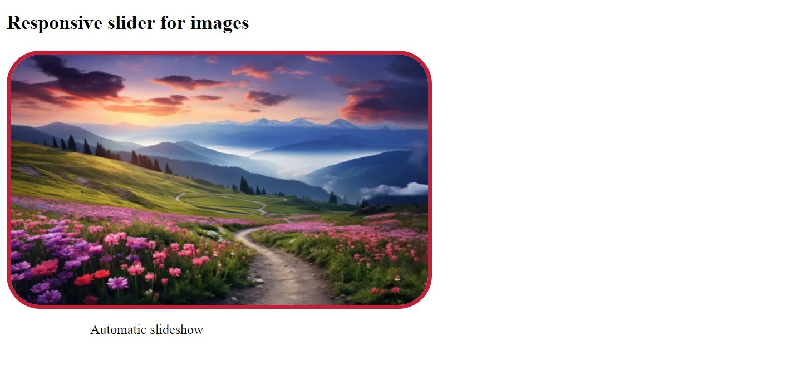

1. Style a list to have custom bullet points and spacing between items.

<!DOCTYPE html>

<html>

    <head>

        <style>

            body{

                background-color: antiquewhite;

            }

            ul{

                background-color: aqua;

            }

            li{

                line-height: 40px;

            }

        </style>

    </head>

    <body>

        <h2>List with bullets</h2>

        <ul>

            <li>Item 1</li>

            <li>Item 2</li>

            <li>Item 3</li>

        </ul>

    </body>

</html>

Output:

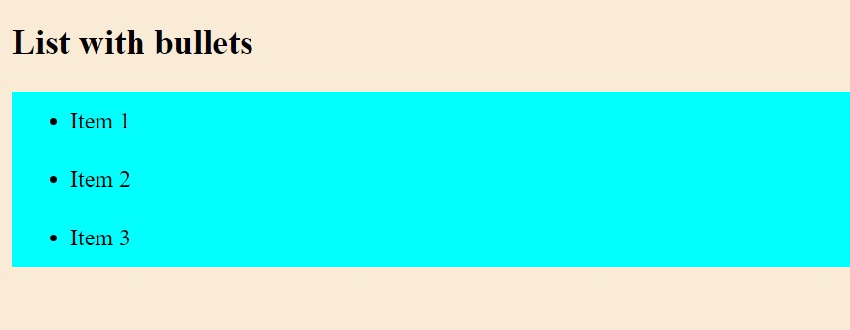

1. Make a website layout that uses a sticky sidebar.

<!DOCTYPE html>

<html>

    <head>

        <style>

            .main{

                display: flex;

                border: 2px solid;

                width: 300px;

                height: 200px;

            }

            .content{

                height: 200px;

                width: 200px;

                overflow: scroll;

                flex-direction: column;

                padding-left: 100px;

            }

            .sidebar{

                position: fixed;

                padding-left: 10px;

                background-color: burlywood;

                height: 200px;

            }

            li{

                list-style: none;

            }

        </style>

    </head>

    <body>

       <h2>Sticky Sidebar</h2>

       <div class="main">

           <div class="content">

               <h4>Key Features of JavaScript:</h4>

               <p>

                   Versatility: JavaScript can be used to develop websites, games, mobile apps, and more. <br><br>

                   Client and Server-Side: With frameworks like Node.js and Express.js, JavaScript is now used for building server-side applications. <br><br>

                   End-to-End Solutions: JavaScript enables developers to create complete solutions for various problems. <br><br>

                   Constant Evolution: JavaScript continually evolves with new features and standards. <br><br>

                   Vibrant Community: A large community of users and mentors actively contributes to JavaScript’s growth.

                </p>

            </div>

                <div class="sidebar">

                    <h4>Sidebar</h4>

                        <li>Home</li>

                        <li>About</li>

                        <li>Products</li>

                        <li>Contact Us</li>

                </div>

        </div>

    </body>

</html>

Output:

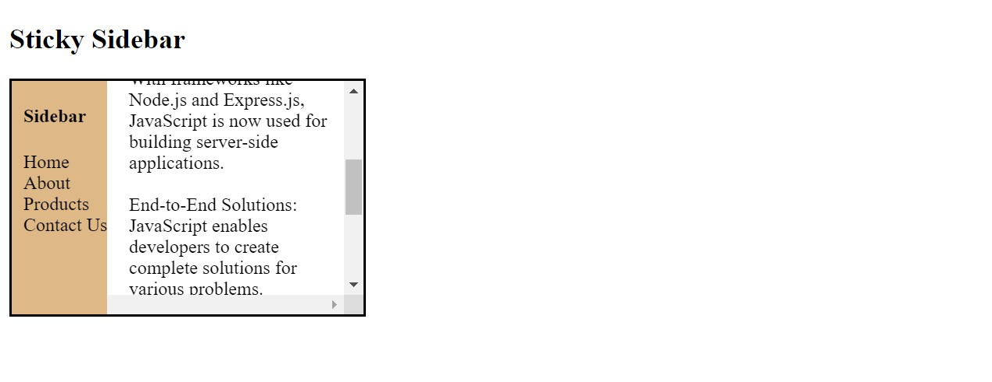

1. Create a simple tooltip using HTML and CSS.

<!DOCTYPE html>

<html>

    <head>

        <style>

            body{

                background-color: rgb(223, 164, 122);

            }

            button{

                background-color: chartreuse;

            }

        </style>

    </head>

    <body>

       <h2>Tooltip</h2>

       <p>Hover mouse on button to see Tooltip</p>

       <button title="Click on the button!">Click!</button>

    </body>

</html>

Output:

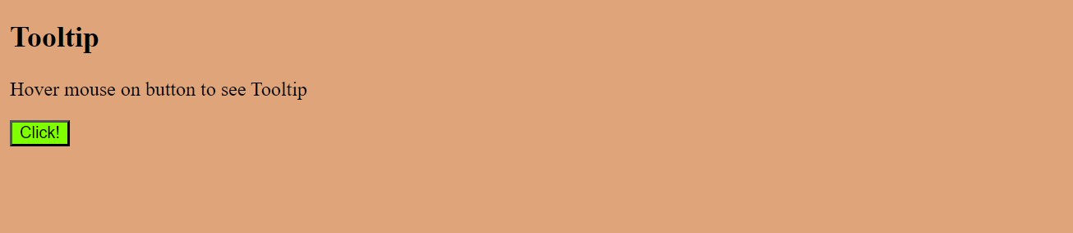

1. Design a card layout for displaying content with an image, title, and description.

<!DOCTYPE html>

<html>

    <head>

        <style>

            img{

                height: 100px;

                width: 200px;

                border: 2px;

                border-radius: 5px;

            }

            .card{

                border: 2px solid green;

                border-radius: 20px;

                height: 220px;

                width: 200px;

                margin: 20px;

                margin-top: 100px;

                padding: 10px;

                background-color:rgb(88, 204, 59);

            }

            body{

                display: flex;

            }

        </style>

    </head>

    <body>

       <h2>Card Layout</h2>

        <div class="card">

            <img src="https://keralakaumudi.com/web-news/en/2023/05/NMAN0413506/image/tiger.1.559435.jpg" alt="Image 1">

            <h3>Tiger</h3>

            <p>National Animal of India</p>

            <p>It is a Carnivorous Animal</p>

        </div>

        <div class="card">

            <img src="https://www.timeforkids.com/wp-content/uploads/2023/11/G3G5_231117_bear_steps.jpg?w=1024" alt="Image 2">

            <h3>Panda</h3>

            <p>National Animal of China</p>

            <p>It is a Herbivorous Animal</p>

        </div>

    </body>

</html>

Output:

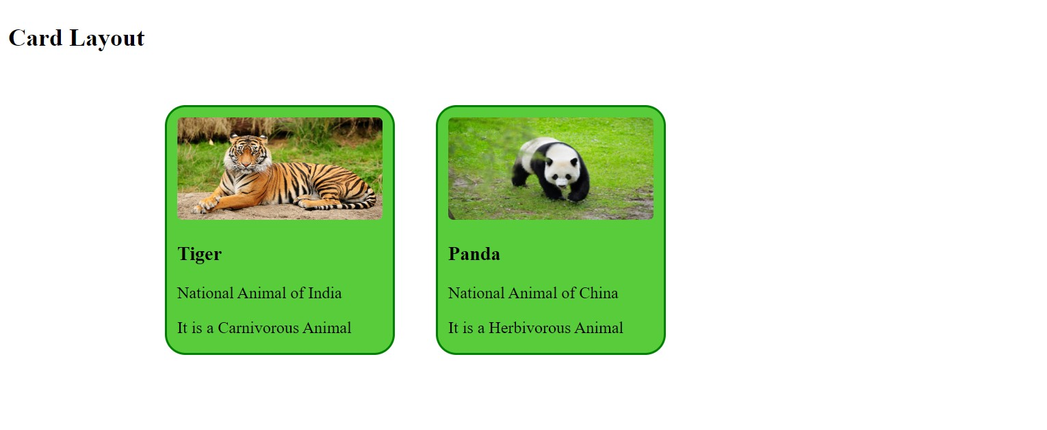

1. Implement a CSS transition on a button to change color smoothly.

<!DOCTYPE html>

<html>

    <head>

        <style>

            button{

                background-color: palevioletred;

                transition-duration: 3s;

                transition: background-color 2s;

            }

            button:hover{

                background-color:yellow;

            }

        </style>

    </head>

    <body>

       <h2>Transition color</h2>

       <p>Hover on button to see yellow color!</p>

       <button>Button</button>

    </body>

</html>

Output:

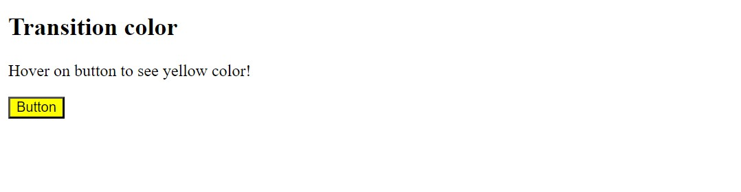

1. Build a responsive navbar with a hamburger menu for mobile devices.

<!DOCTYPE html>

<html>

<head>

<meta name="viewport" content="width=device-width, initial-scale=1">

<link rel="stylesheet" href="https://cdnjs.cloudflare.com/ajax/libs/font-awesome/4.7.0/css/font-awesome.min.css">

<style>

.container {

  width: 300px;

  margin: auto;

  background-color: #555;

  height: 400px;

  color: white;

}

.topnav {

  background-color: #548f42;

  position: relative;

}

.topnav #items {

  display: none;

}

.topnav a {

  color: white;

  padding: 14px 16px;

  display: block;

}

.topnav a.icon {

  background: black;

  display: block;

  position: absolute;

  right: 0;

  top: 0;

}

.topnav a:hover {

  background-color: #993a3a;

  color: black;

}

</style>

</head>

<body>

    <h2 style="text-align: center;">Nav bar with hamburger menu</h2>

<div class="container">

<div class="topnav">

  <a href="#Home">Home</a>

  <div id="items">

    <a href="#About">About</a>

    <a href="#Products">Products</a>

    <a href="#Contact">Contact</a>

  </div>

  <a href="javascript:void(0);" class="icon" onclick="myFunction()">

    <i class="fa fa-bars"></i>

  </a>

</div>

<div style="padding-left:16px">

  <h3>Hamburger menu</h3>

  <p>Click on the menu bar to see the items!</p>

  <p>This is responsive nav bar for mobile devices.</p>

</div>

</div>

<script>

function myFunction() {

  var x = document.getElementById("items");

  if (x.style.display === "block") {

    x.style.display = "none";

  } else {

    x.style.display = "block";

  }

}

</script>

</body>

</html>

Output:

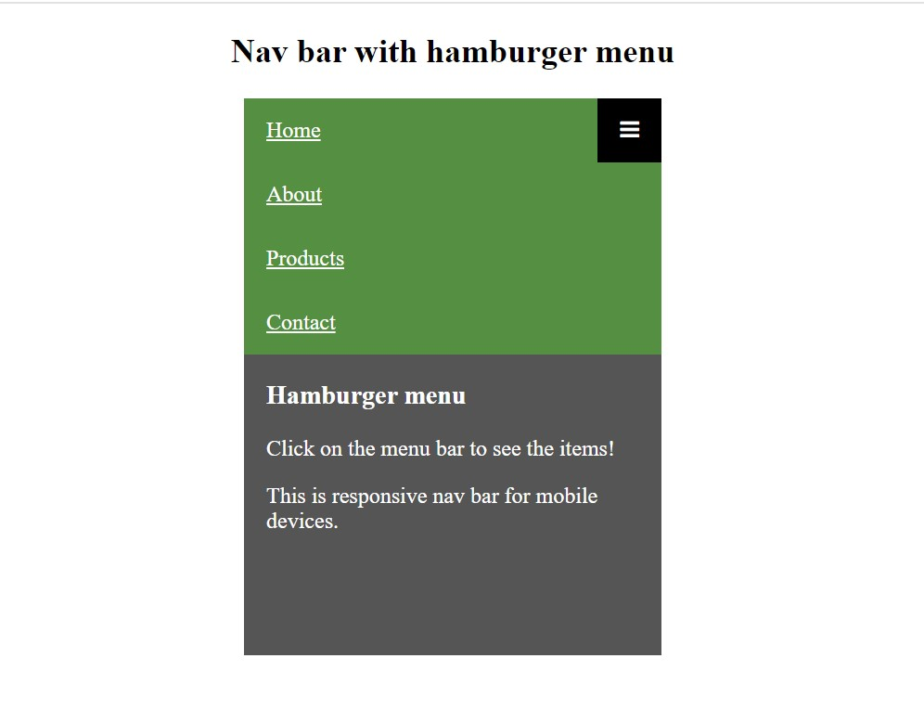

1. Style a table to have alternating row colors and a hover effect on rows.

<!DOCTYPE html>

<html>

    <head>

        <style>

            table{

                border: 3px solid blue;

                border-radius: 10px;

                height: 300px;

                width: 400px;

            }

            th,td{

                border: 2px solid;

            }

            .color1{

                background-color: coral;

            }

            .color2{

                background-color: deepskyblue;

            }

            tr:hover{

                background-color: red;

                cursor: pointer;

            }

        </style>

    </head>

    <body>

        <h2>Styling Table</h2>

        <table>

            <th>State</th>

            <th>Capital</th>

            <th>Language</th>

            <tr class="color1">

                <td>Telangana</td>

                <td>Hyderabad</td>

                <td>Telugu</td>

            </tr>

            <tr class="color2">

                <td>Tamilnadu</td>

                <td>Chennai</td>

                <td>Tamil</td>

            </tr>

            <tr class="color1">

                <td>Maharastra</td>

                <td>Mumbai</td>

                <td>Marati</td>

            </tr>

        </table>

    </body>

</html>

Output:

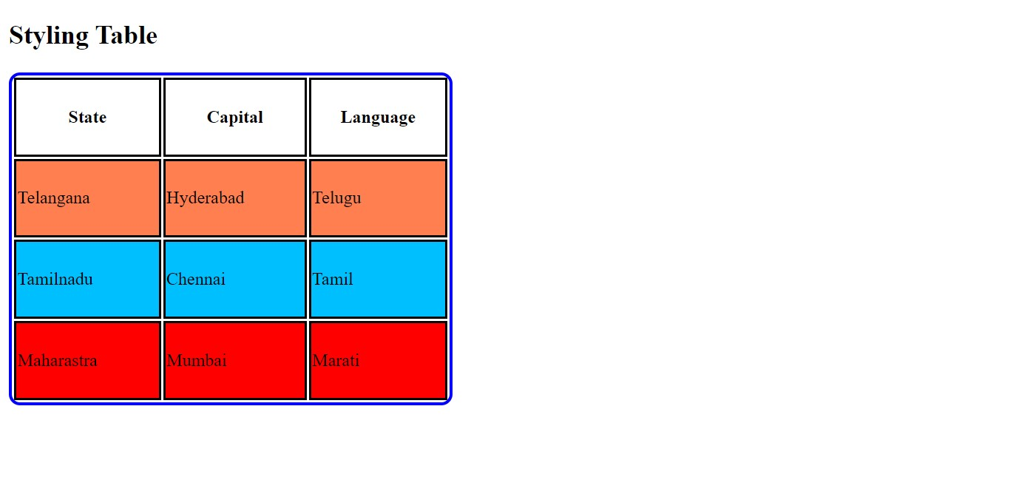

1. Design a progress tracker with steps using HTML and CSS.

<!DOCTYPE html>

<html>

    <head>

        <style>

            progress{

                border: 2px solid;

                border-radius: 5px;

                width: 400px;

                height: 50px;

                background-color: rgb(149, 212, 85);

            }

        </style>

    </head>

    <body>

       <h2>Progress Tracker</h2>

       <progress value="60" max="100"></progress>

        <p>60% completed</p>

    </body>

</html>

Output:

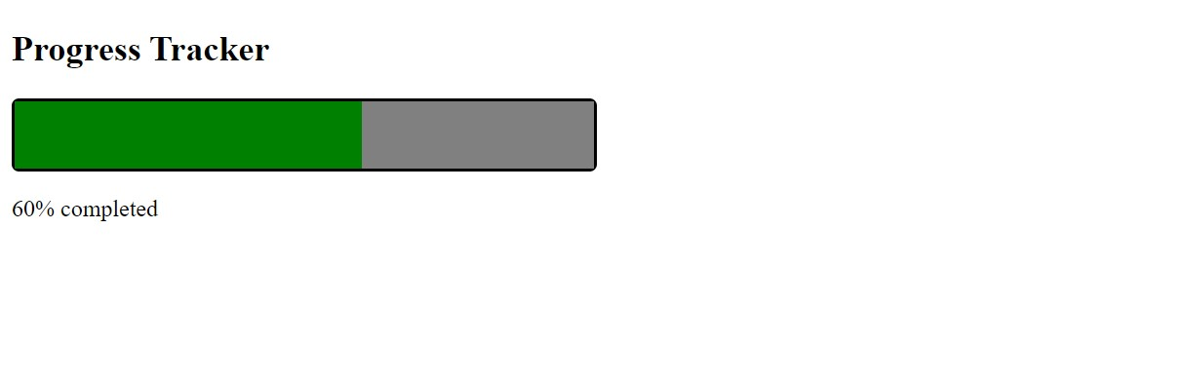

1. Create a parallax scrolling effect on a webpage background.

<!DOCTYPE html>

<html>

    <head>

        <style>

            .main{

                border: 2px solid;

                width: 600px;

                min-height: 700px;

            }

            .parx1{

                background-image: url(https://cdn-prod.medicalnewstoday.com/content/images/articles/325/325253/assortment-of-fruits.jpg);

                background-attachment: fixed;

                background-position: center;

                background-repeat: no-repeat;

                background-size: cover;

                height: 200px;

            }

            .parx2{

                background-image: url(https://freshsensations.com.au/cdn/shop/products/FruitBox.png?v=1643769480);

                background-position: center;

                background-repeat: no-repeat;

                background-attachment: fixed;

                background-size: cover;

                height: 300px;

            }

            div{

                background-color: chartreuse;

                height: 200px;

            }

            </style>

    </head>

    <body>

       <h2>Parallax Scrolling Effect</h2>

       <div class="main">

           <div class="parx1"></div>

           <div>

               <h4>Fruits</h4>

               <p>fruit, the fleshy or dry ripened ovary of a flowering plant, enclosing the seed or seeds. Thus, apricots, bananas, and grapes, as well as bean pods, corn grains, tomatoes, cucumbers, and (in their shells) acorns and almonds, are all technically fruits.</p>

            </div>

            <div class="parx2"></div>

        </div>

    </body>

</html>

Output:

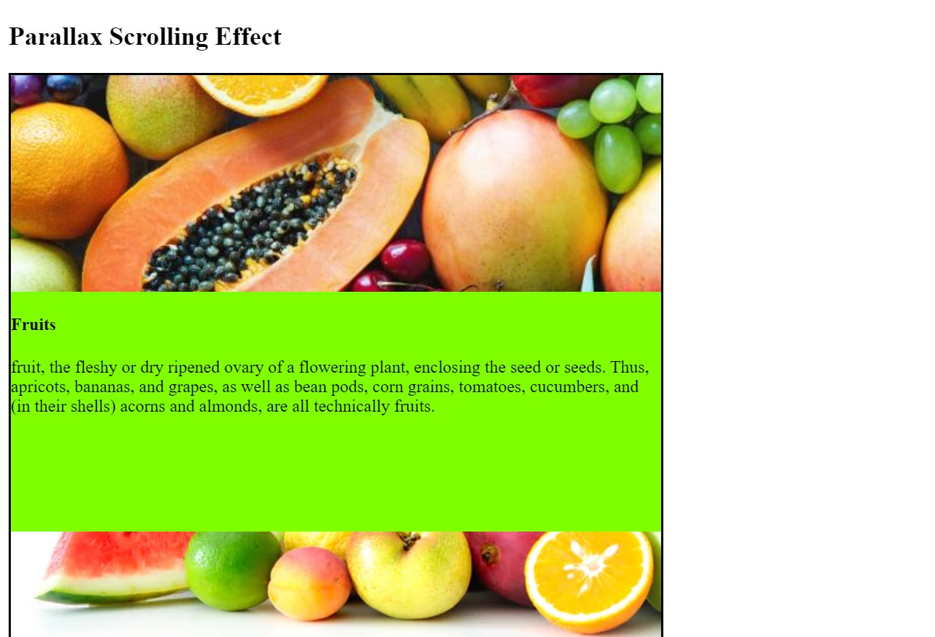

1. Build a dropdown select menu with options styled using CSS

<!DOCTYPE html>

<html>

    <head>

        <style>

            body{

    background-color: rgb(209, 224, 90);

}

.box{

    background-color: rgb(57, 181, 88);

}

input{

    background-color: rgb(171, 45, 141);

    margin-left: 20px;

}

        </style>

    </head>

    <body>

        <h1>Dropdown Select Menu</h1>

        <label for="menu">Menu:</label>

        <select name="Menu" id="menu">

            <optgroup class="box">

                <option value="Item 1">Item 1</option>

                <option value="Item 1">Item 2</option>

                <option value="Item 1">Item 3</option>

                <option value="Item 1">Item 4</option>

                <option value="Item 1">Item 5</option>

            </optgroup>

            <input type="submit">

        </select>

    </body>

</html>

Output:

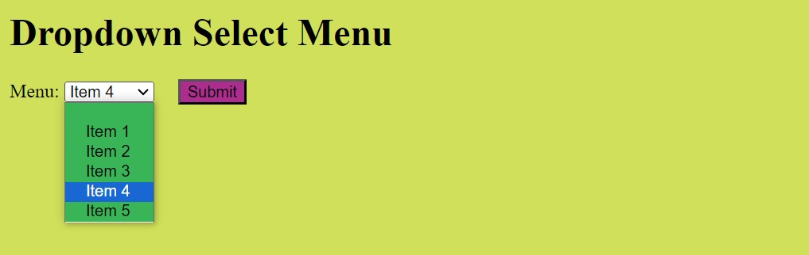

**mini projects:atleast need to complete 4 projects by monday**

1. Portfolio Website: Create a personal portfolio website showcasing your skills, projects, and contact information. Include sections for about me, projects, skills, and contact.
2. E-commerce Product Page: Design a product page for an online store. Include product images, description, price, and add-to-cart functionality.
3. Travel Blog: Build a travel blog website with articles, images, and categories for different destinations. Use CSS to style the layout and make it visually appealing.
4. Restaurant Website: Design a website for a restaurant with a menu, photo gallery, location/map, and contact form for reservations.
5. Event Landing Page: Create a landing page for an upcoming event or conference. Include event details, schedule, speakers, and registration form.
6. Online Resume/CV: Build an online resume or CV with sections for education, work experience, skills, and contact information. Use CSS to make it visually appealing and easy to read.
7. Weather App Interface: Design a simple weather app interface showing current weather conditions, temperature, and forecast for the week.
8. Fitness Tracker Dashboard: Create a dashboard for tracking fitness goals, workouts, and progress. Include charts/graphs to visualize data.
9. Music Player Interface: Design a music player interface with play/pause buttons, volume control, and playlist display.
10. Recipe Blog: Build a recipe blog website with recipes, ingredients, instructions, and cooking tips. Use CSS to style the layout and make it visually appealing.
11. Job Board: Create a job board website where employers can post job listings and job seekers can search and apply for jobs.